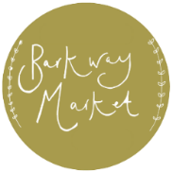**The Village Hall (Barkway Market)**

**Funding application 2025**

The Barkway Market raises money for our local community. It is great news that we have had another successful year and have raised money for local causes. We can now make these funds available. Therefore, we invite applications for funding **from all members of our community groups or individuals**. If you have a request for funding then please complete the enclosed form and submit by Email to info@barkwaymarket.org or post to Barkway Market Funds 2025, The Reading Room, 12, High Street, Barkway, SG8 8EA

Must be submitted by **30/06/25** *(if you have not received confirmation of receipt of application by 20/7/25 please contact 01763 849932)*

All requests will be reviewed by the Barkway Market & Village Hall Committees and applicants will be informed as soon as possible.

**Name of applicant:**

**Telephone number:**

**Email address:**

**Name of organisation (if applicable):**

Please submit details of your request for funding and include the following details (250 words maximum):

* For what you would like funding
* How much money you require
* What you have done already or plan to do to raise additional funds
* How it benefits our community.

Thank you

Signed: Date: